

Consent Form

Master of Research Study, Intellectual Disabilities and Social Media Interview

|  |  |
| --- | --- |
|  | This consent form is for people who want to be part of our study. |
| http://cdn.shopify.com/s/files/1/0606/1553/products/Confused5_large.png?v=1417852505 | The **consent form** says that you:   * understand what the study is about * want to be part of it * are willing to show and share some of your own posts and comments. |
|  | The study is about people with intellectual disability and how they use social media. |

|  |  |
| --- | --- |
| **What you need to do** | |
|  | You must read the consent form. |
|  | You must circle the boxes that you say yes to. |
|  |  |
|  | You must sign the consent form. |
| **The consent form** | |
|  | My name is: |
|  | I want to be part of this study.  Yes No  Shape, arrow  Description automatically generated http://cdn.mysitemyway.com/etc-mysitemyway/icons/legacy-previews/icons/rounded-glossy-black-icons-alphanumeric/074201-rounded-glossy-black-icon-alphanumeric-x-mark.png |

|  |  |
| --- | --- |
|  | I understand what this study is about.  Yes No  http://cdn.mysitemyway.com/etc-mysitemyway/icons/legacy-previews/icons/rounded-glossy-black-icons-alphanumeric/074201-rounded-glossy-black-icon-alphanumeric-x-mark.png |
|  | I have read the information about the study.  Yes No  http://cdn.mysitemyway.com/etc-mysitemyway/icons/legacy-previews/icons/rounded-glossy-black-icons-alphanumeric/074201-rounded-glossy-black-icon-alphanumeric-x-mark.png |
| http://cdn.shopify.com/s/files/1/0606/1553/products/Confused1_large.png?v=1417852498 | I can ask the people from the study if I have any questions about it. |
| http://cdn.shopify.com/s/files/1/0606/1553/products/Cross_No_large.png?v=1417856332 | I know that I don’t have to be in the study if I don’t want to. |
| Image result for people leaving | I know that I can stop doing the study at any time. |
|  | I know that I don’t have to answer any questions that I don’t want to. |

I know that the researcher won’t tell anyone what I say when we talk.

 I understand that my personal information will only be shared with my consent, unless required by law.

I know that they will share what they find out in the study.

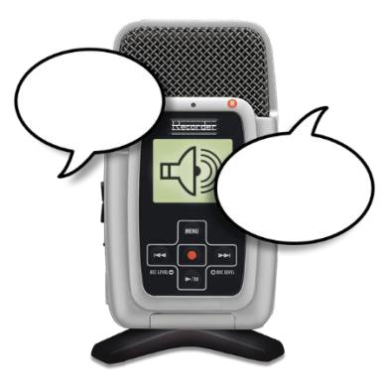I understand that my answers will be digitally recorded.

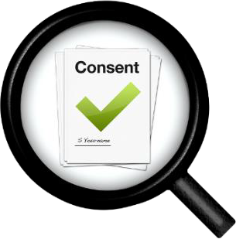To say yes to this consent form you must sign it.

W

|  |  |  |
| --- | --- | --- |
|  |  | Sign your name in the box |
|  |  | rite the date in the box |
|  |  | would like to hear about what the study found Yes No |

I .



If you circled yes please provide an email address in the box.

**Declaration by researcher:** I have explained the project to the participant who has signed above. I believe that they understand the purpose, extent and possible risks of their involvement in this project.

|  |  |  |  |  |
| --- | --- | --- | --- | --- |
| Research Team Member Name |  | Research Team Member Signature |  | Date |

NOTE: If you are signing this consent form you must also date your own signature.